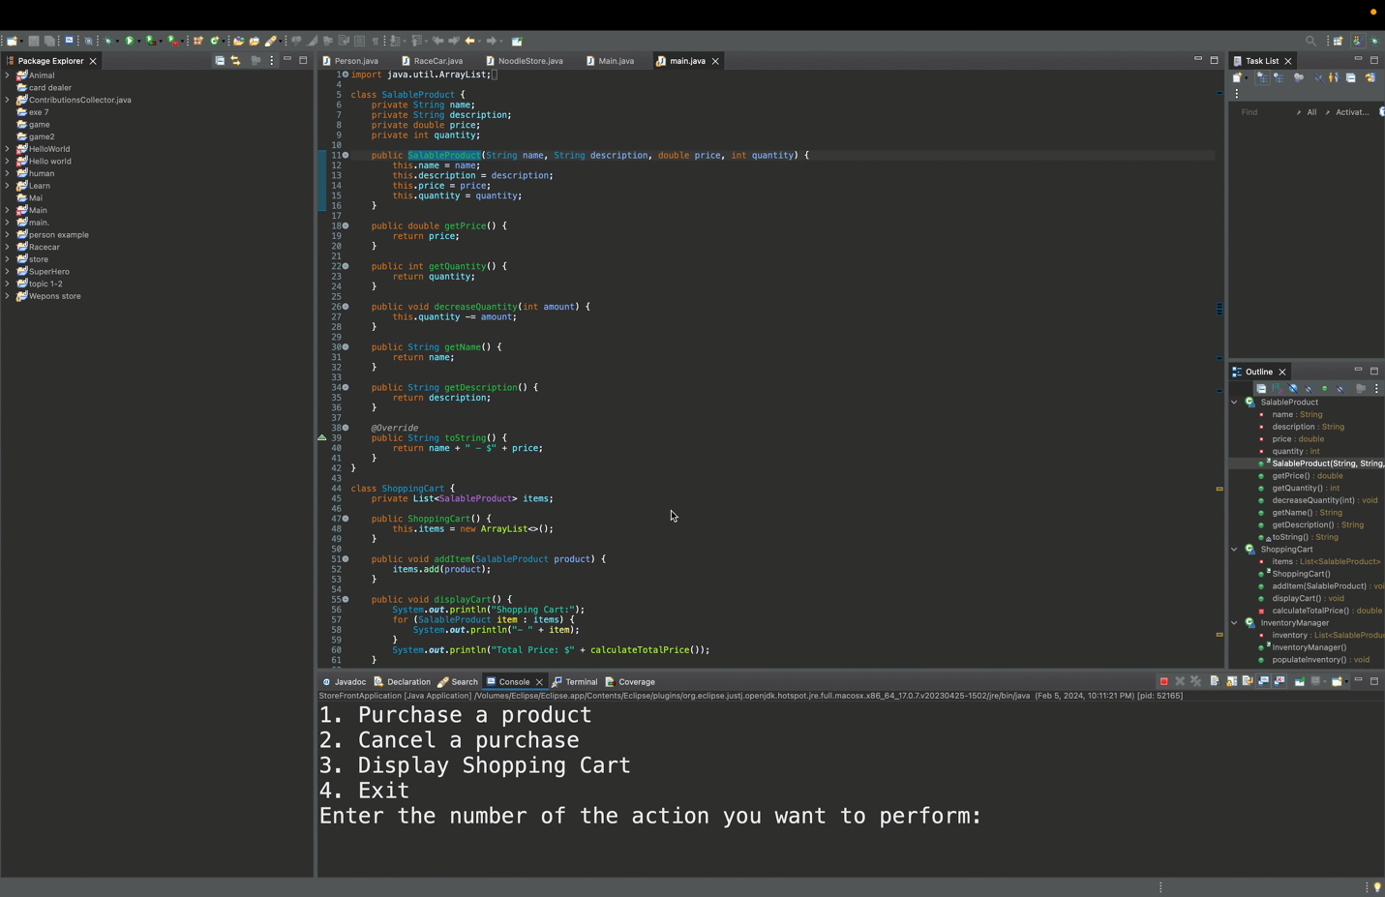Milestone 2: Video explanation for milestone showing all things used.

This is the flowchart for milestone 2 explaining how the code was made